Technical Datasheet of WIN-PiHAT-8AI
1. Overview
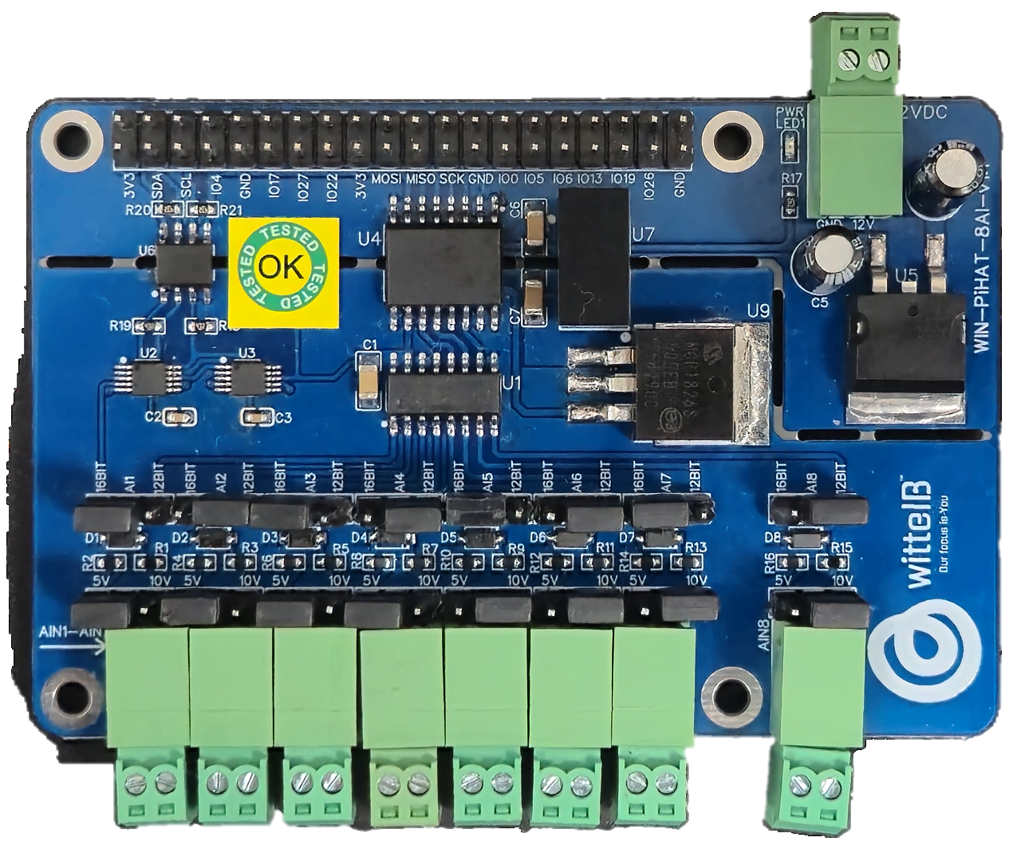
The Analog Input (AI) PiHAT is an 8-channel expansion board for Raspberry Pi 4 and CM4, offering high-resolution analog inputs for industrial data acquisition. It provides precise signal measurement by supporting both 12-bit and 16-bit data resolution, ensuring accurate data collection between external analog sensors and the Pi’s GPIO header for reliable operation in industrial environments.

This PiHAT features a scalable architecture supporting 1 to 8 independent analog inputs (AI). Its population-based design allows channel flexibility while maintaining a compact and reliable solution for embedded sensing, automation, and precise industrial measurement applications.

Specifications
Category | 8AI PiHAT
Input Type | High-Resolution Analog Inputs,  Selectable 12-bit or 16-bit ADC Resolution
Channel Count | 8 Channels (Expandable Design Architecture)
Connectors | 2.54 mm Pluggable Terminal Blocks (for sensor inputs),  40-Pin Raspberry Pi GPIO Header

General :–

Dimensions 56 mm L x 85 mm W
Power Input Power – 12/24V DC
Operating Temperature 0 – 60° C (32 ~ 140°F)
Storage Temperature -20 - 70° C (-4 ~ 158°F)
Storage Humidity 5 ~ 95 % RH, non – Condensing
Certifications 

AI (Analog Inputs) :–

Channels 8
ADC Resolution 12-bit / 16-bit (Selectable)
Input Type Single-Ended / Differential (Depending on config)
Voltage Input Range 0 ~ 5V DC, 0 ~ 10V DC
Current Input Range 0 ~ 20mA, 4 ~ 20mA
Input Impedance(V) ≥ 1 MΩ
Input Impedance(I) ~ 250 Ω (Typical for mA drop)
Accuracy ±0.1% to ±0.3% FSR (Full Scale Range)
Sample Rate Programmable (e.g., 8 SPS to 860 SPS)
Isolation / Protection Over-voltage protection up to [Insert Max V, e.g., 30V]

Configuration :-

All 8 AI channels operate as high-resolution analog inputs and are interfaced to the Raspberry Pi GPIO header through an onboard Analog-to-Digital Converter (ADC) IC. Data acquisition is managed via software running on the Raspberry Pi. Each channel is configured to continuously monitor and sample incoming signals from external industrial sensors.

When an analog signal (such as a 0-10V or 4-20mA output from a sensor) is applied to an input terminal, the ADC processes this continuous signal and converts it into a precise digital value (using either 12-bit or 16-bit resolution). The Raspberry Pi retrieves these digital values over the communication bus (typically I2C or SPI), allowing your software to accurately scale, log, and react to real-world measurements.

The following are step by step guides for configuration:
- Connect the Module to +12/24V DC POWER SUPPLY.
- Connect the Board to the Raspberry Pi via header pins

Bus Type | Signal Name | Pi GPIO | Header Pin Number | Description
I2C | SDA | 02 | 03 | I2C data line for 2 of ADS1115
 | SCL | 03 | 05
SPI | MOSI | 10 | 19 | SPI data line for MCP3208
 | MISO | 09 | 21
 | SCLK | 11 | 23
 | CE1/CS | 07 | 26

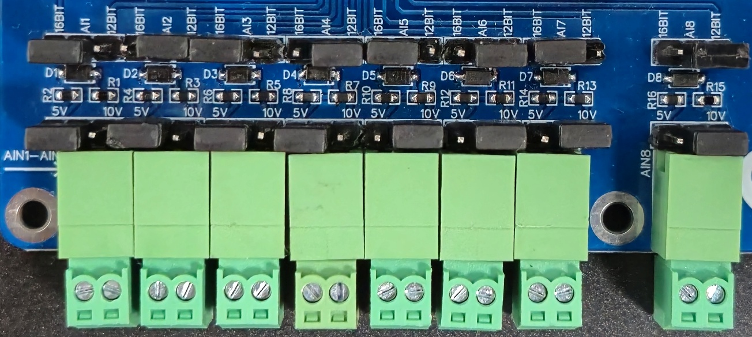
Wiring Diagram:-
AI1-8
GND

- Analog Input (AI) Operation: Each channel provides two terminals: + (Positive) and - (Negative/Common). These are used to read external analog sensor signals.
- Channel Configuration (Visual Guide): Each of the AI channels features two dedicated jumpers to independently set the voltage range and bit resolution.
  - Voltage Range Selection: Place the voltage jumper on the 5V position to read 0-5V signals, or on the 10V position to read 0-10V signals.
  - Resolution Selection: Place the resolution jumper on the 12-bit position for standard data acquisition, or on the 16-bit position for high-precision measurements.
- Sensor Wiring Connections:
  - The analog sensor's positive signal wire should be connected to the + terminal of the desired channel.
  - The sensor's common or ground wire should be connected to the corresponding - terminal.
- Crucial Setup Recommendation: Always ensure that the voltage jumper setting strictly matches the maximum output range of your connected sensor (either 5V or 10V) guarantee accurate analog-to-digital conversion and prevent data clipping

Sample Test Code: WIN-PiHAT-8AI
Hardware Interface & Connector Layout:
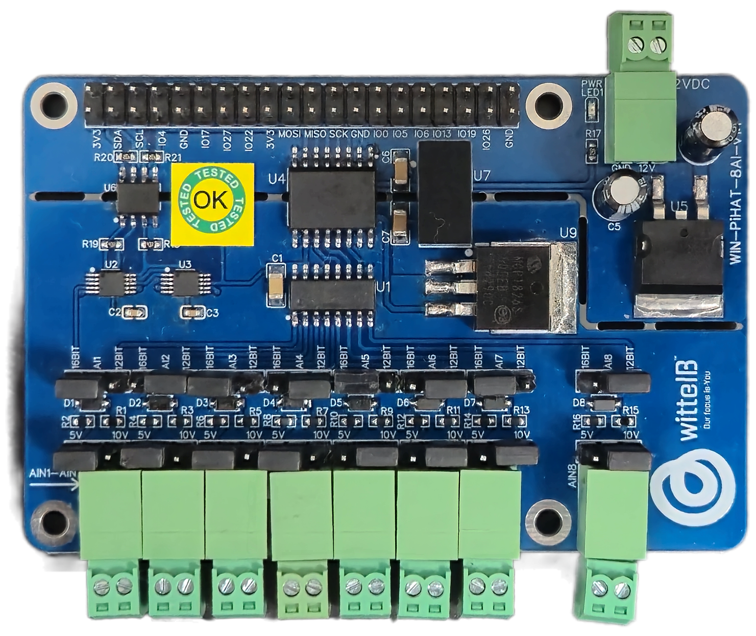
40 pin GPIO Headers
12/16 BIT JUMPER
12/24V DC SPLY
AI1 AI2 AI3 AI4 AI5 AI6 AI7 AI8
ANALOG INPUT
2
1
40
39
POWER LED

0-5/0-10V
JUMPER

Contact us: -
Augmatic Technologies Pvt. Ltd.,
Plot no 6, Shah Industrial Estate II,
Kotambi,
Vadodara – 391510.
Email – Sales@wittelb.com

